**What is Neuroscience?**

Same as, study of space is space science, study of medical is medical science, et cetera. A scientific approach of study of a biological nervous system and brain is called Neuroscience.

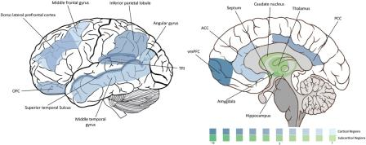

**What is a Biological Neuron?**

**____________________________**

**What is a Biological Neuron?**

A neuron is the smallest unit of biological brain cell, which is connected to other neuron cell to make a neuron network.

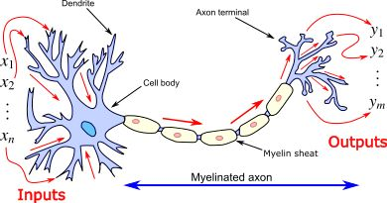

**Dendrite:** Fibre branch of a neuron which conveys information or we can say input path for neuron. It always gets input from axons of the other neuron cell.

**Cell Body (Soma)**: it integrates all the inputs from dendrites.

**Axon:** The fibre body emanate (spread out of a source), and it always transmit the signal to dendrites of other soma (cell body).

**What is Neuron Synapse?**

**____________________________**

**What is Neuron Synapse?**

A synapse is a structure at axon terminal that permits a neuron to pass an electrical signal to dendrite of another neuron.

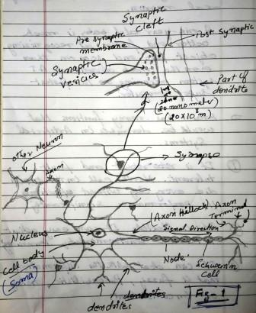

**How do Neuron works?**

**____________________________**

**How do Neuron works?**

Human brain consists of an estimated 100 Billion nerve cells or neurons. Neuron communicates via electric signal that are short electric impulse or spike in the cell membrane.

The transmission of the signal take place at synapse, which is a complex chemical process in which transmitting substance are release from pre-synaptic side at the synapse junction. The impact is to increase or decrease the electric difference inside the cell body of receiving cell at post-synaptic area.

As soon as the potential difference reaches at a threshold an electric pulse of a fixed strength and duration is sent to the axon of the sending cell. This phenomenon is called cell has “fired”

Before next fire, cell has to wait for some time which is called ‘Refractory period”, based on input information and potential threshold, the cell is ready to fire again.

The potential difference between inner and outer cell membrane is -70mV

**What is Action Potential Propagation?**

**What is Neural Network (NN)?**

**____________________________**

**What is Action Potential Propagation?**

The initial generation of an Action Potential usually take place in the axon hillock (the segment axon just next to the soma.

Action Potential is then propagating along the axon to the location where axon form synapses with other neuron at the axon terminal.

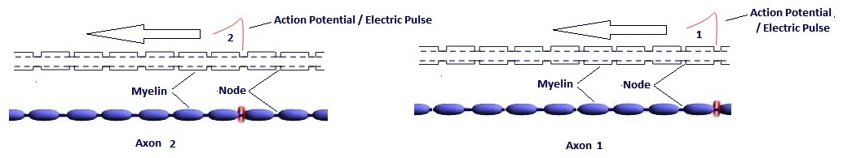

**What is Neural Network (NN)?**

A neuron is the smallest unit of biological brain cell, and a neural network is inter-connectivity between these neurons. Neuron network make possible for information exchange. Neuron network is a building block of cognition.

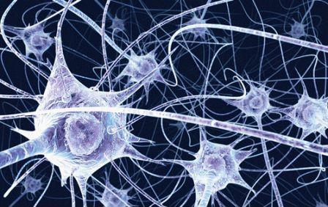

**What is Artificial Neural Network (ANN)?**

Computer is much faster than human brain, but cannot make its own decision, so computer scientists are trying to mimic real biological neuron to enable computer for cognition and they term it as Artificial Neuron. And an artificial neural network is inspired by inter-connectivity between the real biological neurons.

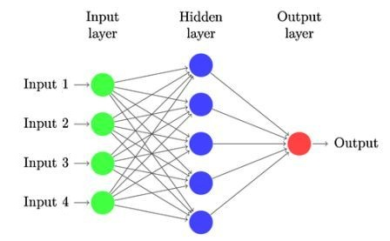

**What is the use of Artificial Neuron Network?**

**What is Feed-Forward & Feed-Back (Recurrent Connection)?**

In constraint of learning, decision making, logical thinking, feelings, common sense, human brain is much better than computer, but the processing speed of computer is much faster as compare to the brain. Hence computer scientists are trying to mimic human brain which will help us faster than biological brain in below mentioned field

Share Market Finance Prediction

Prediction in Space Science

Character recognition

Speech recognition

Image Processing

English text pronunciation

Medical diagnosis and prediction

Control vehicles autonomously

Facial Expressions Recognition

Predicting drugs effects

Improving optical communication

Et cetera.

**What is Feed-Forward & Feed-Back (Recurrent Connection)?**

1. **Feed-Forward Network Connection:** This is the simplest neuron connection type in which data flow is in one direction only from Input Layer 🡪 Hidden Layer 🡪 Output Layer.

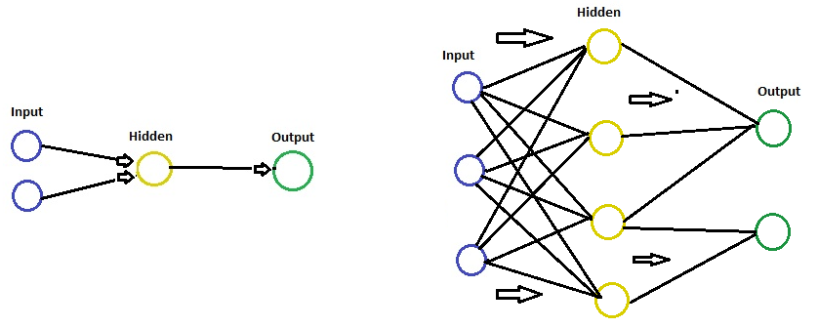

1. **Re-current or Feedback Network Connection:** In this data flow is in backdirection too, looping occurs, like Input Layer 🡪 Hidden Layer 🡪 Hidden Layer 🡪 Output Layer.

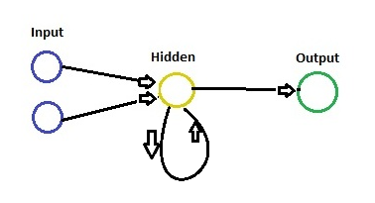

**What are the basic properties of Artificial Neuron Network (ANN)?**

The Activation of a unit depends on it receives input from incoming connection and their weights.

Input values are independent variable. Ex –age of the person, Money in back account,

Output values can be Continuous (price), Binary (Y/N, 1/0), Categorical Variable (Animal, Fruit, Vegetable – there could be more than one or several output. As these are representing categories.

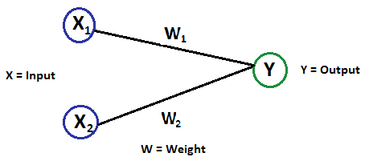

**Y= f (x1.w1 + x2.w2)**

**What is Machine Learning (ML)? | What are the types of Machine Learning?**

In the field of Artificial Intelligence (AI), Machine learning is a scientific algorithm to make a computer system able to think and take decision autonomously like human,

There are four types of Machine Learning (ML):

1. **What is Supervised Learning?**
2. **What is Unsupervised Learning?**

**____________________________**

**What is Supervise Learning?**

**Before understand Supervised learning we must be aware of the following terminologies**

**What is Regression:** Thisterm isused forthe goal to predict continuous real value, such as “pound”, “weight”, “distance”, et cetera.

(For **example**, if you measure a child's height every year you might find that they grow about 3 inches a year.)

**What is Classification:** Thistern is used for the goal to predicted output category, such as True/False, 1/0, Green/Yellow, spam/ not spam, Ill/Healthy

**What is Labelled data**: Data consisting of a set of *training examples,* where each example is a *pair* consisting of an input and a desired output value (also called the *supervisory signal, labels*)

**What is Supervise Learning?**

The majority of practical machine learning uses supervised learning algorithms, which is designed to learn by example, where we have input variables “x” and an output variable “Y” and we use an algorithm to learn the mapping function from the input to the output.

y = f(x)

Where “y” is the desired output of input function value “x” based on machine learning model during training.

Example:

|  |  |  |  |  |
| --- | --- | --- | --- | --- |
| **NO.** | **SIZE** | **COLOR** | **SHAPE** | **NAME** |
| 1 | Big | Red | Rounded shape with a depression at the top | Apple |
| 2 | Small | Reddish Yellow | Round shape | Apricot |
| 3 | Big/small | Green | Long cylinder with curve | Banana |
| 4 | Small | Black | Round to oval | Blackberry |
| 5 | Small | Green | Elliptical | Avocado |

Let’s assume, we have taken a new fruit from the basket then we observe the size, colour and shape of that fruit.

 If size is Big, colour is Red, shape is rounded with a depression at the top, we will confirm the fruit name is apple and we will put in apple group. And similarly for the other fruits in the basket too.

Hence, in this way the task of grouping the fruits is completed successfully.

We can observe in the table that a column was labelled as “**NAME**” this is called as "**Response Variable**".

 If we have learnt the thing before from the training data and then applying that knowledge to the test data (for new fruit), this type of learning is called as **Supervised Learning.**

The goal is to approximate the mapping function so well that when we have new input data (x) that we can predict the output variables (Y) for that data.

The term **supervised learning** came from the idea that an algorithm is learning from a training dataset

Training data for supervised learning includes a set of examples which is paired with input subjects and desired output (which is also referred to as the supervisory signal).

**Common supervised machine learning algorithms are:**

Logistic regression

Linear regression

Linear discriminate analysis

Decision trees

Bayesian logic

Support vector machines (SVM)

Similarity learning

Random forests

Linear Classifiers

K-Nearest Neighbors

**What is Unsupervised Learning?**

*To understand the Unsupervised Learning, it is suggested to be getting familiar with Supervised learning from* ***HERE****.*

Unsupervised learning is the opposite of supervised learning, because a training set is not available hence data is used without labelled and we are unsure about the output. Unsupervised learning can understand the data patterns and finds structures in that.

Unsupervised learning algorithms are used to group cases based on similar attributes of data set. These models also are referred to as self-organizing maps.

Real Example: In android phone, Google Photos app has a feature which can categorize and makes an album of the photo based on the person. Well, its image processing algorithm is working, but the app is grouping the person with similar face patterns in multiple photos.

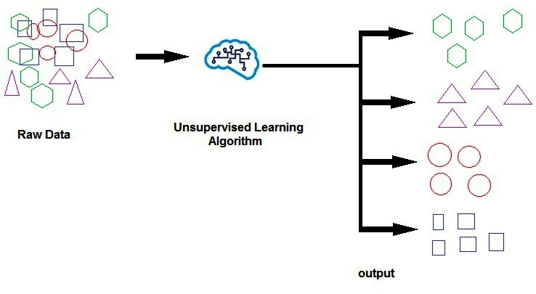

Popular clustering techniques in Unsupervised learning include:

1. K-Means Cluster
2. Hierarchical Clustering.

**____________________________**

**What is K-means cluster?**

A group of similar data type is termed as “cluster”, which is a collection of data type collected together because of certain similarities in the data set.

Example:

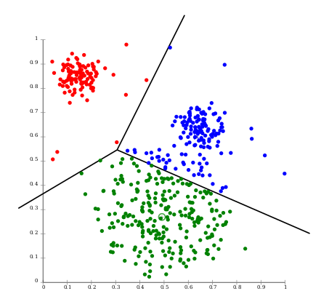

K-means clustering is one of the simple as well as most popular unsupervised machine learning algorithms. The goal of clustering is to create groups of data points such that points in different clusters are dissimilar while points within a cluster are similar.

The k-means the algorithm takes as input the number of clusters to generate “k”, and a set of observation vectors to cluster. It returns a set of centroids /code vectors, one for each of the k clusters. The centroids/code vectors are like the soul of the cluster, they search the points closest to them and add them self to the respective cluster

With k-means clustering algorithm, we make a cluster of our data points into k groups. A larger “k means” creates smaller groups with more granularity, whereas lower “k means” creates larger groups and **fewer granularity.**

**Steps for k-means clustering:**

1. Place K code vector randomly in data
2. Divide up the data into K partition according to the closest code vectors
3. Keep repeating point 2, and moving the each code vector to the means of its partition. Until code vectors stop moving.

Note: “K mean” may produce different clustering when run multiple times on same data.



**What is Hierarchical Clustering?**

**____________________________**

**What is Hierarchical Clustering?**

## Hierarchical Clustering unsupervised learning algorithm in which each element treated as a standalone cluster.

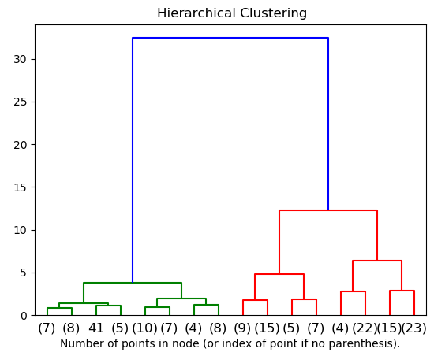

## Working of hierarchical clustering:

Hierarchical Clustering unsupervised learning algorithm in which each element treated as a standalone cluster and then iteration executes the following steps:

Firstly: identify the two clusters that are closest together

Secondly: Merge the two most similar clusters together. And this iteration continues until all the similar clusters are merged together.

**What is spatial Integration or summation? |**

**What is Temporal Integration or summation?**

**Spatial Integration or Summation**: When multiple presynaptic of others neuron fire together and release enough charger to exceed the threshold of the postsynaptic one’s neuron is called **Spatial Summation or Integration.**

**For example**, Presyanptics of neuron **A**, neuron **B,** neuron **C** and so on fire together but individually they release insufficient charge, but when all these charges are summed or integrated together then it may exceed the threshold and cause an action potential fire on neuron **X**.

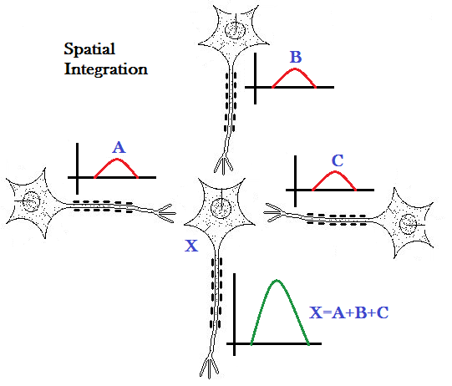

**What is Temporal Integration or summation?**

**Temporal Integration or Temporal summation**: When Presynaptic of another individual neuron initiate multiple fire over a period of time, the total charger collected together may have enough potential to exceed the threshold of the postsynaptic of another connected neurone is called **Temporal** **Summation or Integral**.

Action Potential frequency is directly proportional to the Threshold, means higher the frequency of fire, the more quickly exceeded the threshold.

**For example**, Presyanptics of neuron **A** individually fires an insufficient charge at a time, but when it fires continually, all the charges are summed or integrated together then it may exceed the threshold and cause an action potential on neuron **X**.

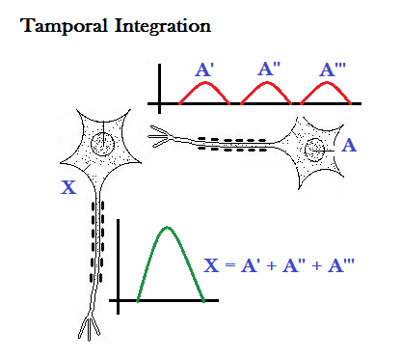

**What is spatial Integration or summation?**

**What is Synaptic Plasticity?**

**Plasticity** means mutable or changeable.

To increase or decrease the synapse activity, they have ability to be weakening or strengthen over time which is termed as Synaptic Plasticity. The plasticity is done by changing or altering the number of neuro-transmitter receptor located on synapse. It manage the how effectively two neurons communicate with each other

(The strength of communication between two **synapses** can be likened to the volume of a conversation. When neurons talk, they do so at different volumes – some neurons whisper to each other while others shout.)